Leader Guide to Annual Performance Planning

Table of Contents
Introduction 3
Additional Resources 3
How to use this guide 3
Establish Performance and Learning Goals 4
Performance is a Partnership 4
Step 1: The Whole Person 4
Step 2: Strengths and Challenges 5
Step 3: What, Why, and How? 6
Step 4: SMART Performance Goals 7
SMART Worksheet 8
Strengthen WSU Values 9
Plan For Professional Development 10
Step 1: Align Learning Activity to Performance Goals 10
Step 2: Assess Current and Needed Proficiency Level 10
Step 3: Identify Actions to Take 11
Step 4: Maintain Momentum 11
Plan for Career Development 12
The Career Mobility Model 12
Step 1: Deepen Self Insight 13
Step 2: Develop Initial Career Goal & Development Plan 14
Step 3: Research Roles and People/Practice Opportunities 16
Step 4: Solicit Support 19
Step 5: Get Resume-Ready for Open WSU Postings 22
Step 6: Interview SMART 28

Introduction
This Guide follows along with the instructor-led webinar series, “Cornerstone Conversations.” It includes thought-starters and reflection questions to help write great performance goals and plan for professional and career development. Use the mini worksheets and prompts to identify topics for follow-up discussions and opportunities to see and offer support.

Additional Resources
Learning resources can be found on the Cornerstone Learning Resources website.
Also, see the Cornerstone User Manual for help with navigation and step-by-step instructions.

Plan for Success is the first element in the performance management process. It includes three pivotal activities: setting performance and learning goals, planning for professional development, and planning for career development.

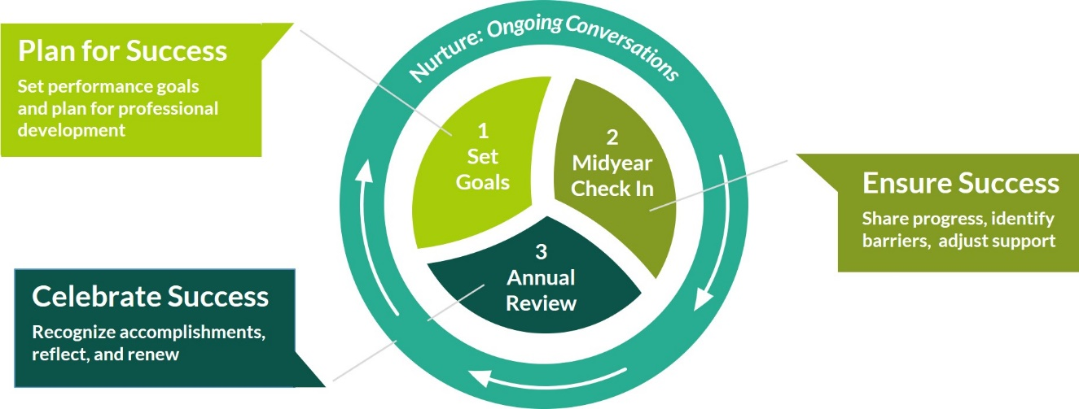

How to use this guide
This guide provides information, reflection questions and resources to assist you throughout each of the planning activities.
- Reflect on the questions and capture thoughts with yourself and your staff in mind.
- Refer to it as you add information into Cornerstone, add comments to edit and/or approve goals.
- Review before scheduling ongoing conversations with your manager and staff to track progress, provide feedback, celebrate success, ask questions, and make adjustments along the way.

Establish Performance and Learning Goals

Performance is a Partnership
Each of us is the hero of our own success story.

Like a book, we can reflect on and learn from past chapters, live fully in the story we’re writing today, and plan for what we envision on our unwritten pages. As a supervisor you are writing your story and are part of the editorial team for your staff members, providing information, support, feedback, guidance, and clarity to enable them to achieve their performance and learning goals.

Step 1: The Whole Person
Great goals begin with a focus on the Whole Person. Use these prompts to think about your values, interests, professional and personal goals. How would you answer these? What could you learn about your staff members that would be important in setting team and individual goals?

Values: What characteristics, qualities and beliefs are at the core of who I am and how I live?

Purpose & Passions: What am I passionate about (what energizes me)? What motivates me to act? When am I enthusiastic about a project or a cause?

Professional Vision: Where do I see myself in the next year? In the next 2-4 years? What vision can I imagine for my professional career in the future?

Personal Vision: What do I imagine for my personal life in the future? What do I want to accomplish? Who do I aspire to be?

Step 2: Strengths and Challenges
Make a quick inventory of your strengths and challenges.

Strengths
- What skills, knowledge, qualities or attributes do I believe are my strengths?
- What do others come to me for my expertise in something?
- When am I ‘in my element’ and achieving my goals?
- What are my gifts and talents?

Challenges
- What areas of my work life do I find particularly challenging?
- What skills, knowledge, qualities or attributes would I like to improve?
- What do others think I need to work on?
- When do I feel frustrated?

Which are important for you/your staff in the year ahead?

Who possesses or can develop them?

Are there any gaps to fill?

Step 3: What, Why, and How?

What do you need staff to do? List critical job tasks, responsibilities or outputs (information or services they provide to you and others). Example: Provide reports on time.

- ___________________________________________________________________
- ___________________________________________________________________
- ___________________________________________________________________
Ongoing Discussion Points:
- What will continue from last year? What might need to be added, changed or stopped?
- Who does your staff give their work to (supervisor, team member, student, other)? How have these ‘internal customers’ needs changed?

Why does your team do what you do? Using the tasks above, add what will change as a result of doing this work. Example: Provide reports on time to improve customer service.

- ___________________________________________________________________
- ___________________________________________________________________
- ___________________________________________________________________

Ongoing Discussion Points:
- How does this support/enable team and department goals?
- How does this help achieve WSU strategic goals, mission and vision?
- Strategic Plan Website

How does work get done?

What has changed for you (personally and/or professionally) that could be important to share in Ongoing Discussion Points with your manager/your team as you establish goals together?

- Job requirements – new skills, knowledge, etc.
- Team goals and makeup
- Customer requirements
- Personal circumstances – family needs
- Where we do our work (onsite, remote, hybrid)
- Technology, communication and collaboration needs
- Stage in your career
- Other?

Step 4: SMART Performance Goals
Use the SMART approach to goal writing to:
- Clearly define expectations for performance
- Provide staff with meaningful feedback (feedback is information that helps someone do their job better) e.g., coaching, recognition for performance, correction, support, etc.
- Serve as a basis for modifying or changing behavior
- Provide objective, documented and supportable information for making personnel decisions
- Encourage ongoing performance conversations

Make it SMART - Example from above: Provide reports on time to improve customer service
Specific: (specific report names every Friday by 5pm)
Measurable: (increase satisfaction score by 50%, 100% proactive calls vs. reactive calls)
Achievable: (increase satisfaction score by 25%, positive trend in proactive calls)
Relevant: improving customer service will build stronger relationships, position us a credible partner and ultimately, contribute to the WSU strategic focus area of operational excellence
Time-bound: by end of fiscal year

Re-written Goal: Improve customer service with an increase of 25% in the satisfaction survey score and an increase in (#) number of proactive calls by the end of the fiscal year by providing XYZ reports every Friday no later than 5pm.

Ongoing Discussion Points:
- What do different levels of performance look like (e.g., “meets” or “exceeds expectations”)?

SMART Worksheet
Use the SMART format to write goals. Test one of the statements you captured in Step 3 or use one of your/your team’s goals.

My Goal:

Specific? Measurable? Actionable? Realistic? Timely?
Can you make it SMARTer?

Team Goal:

Specific? Measurable? Actionable? Realistic? Timely?
Can you make it SMARTer?

Individual Cascade Goal:

Specific? Measurable? Actionable? Realistic? Timely?
Can you make it SMARTer?

✓ Cornerstone Action:
Add, comment, edit and approve goals in Cornerstone
Schedule goal planning conversations with staff.
See User Manual for step-by-step instructions

Strengthen WSU Values
Performance is a combination of what we do and how we do it. Our Wayne State values embody how we approach our work and interact with each other. Reflect on your thoughts in the Whole Person activity (Step 1). What WSU values are important to you personally and professionally? Why?
Ongoing Discussion Points:
- Are there aspects (behaviors) within the values that you have strengths in? How can you help reinforce this in others? (recognition, learning, etc.)
- All of our values are foundational to achieving WSU strategic goals and creating a culture where everyone can thrive. Is there one that is particularly important to you and your work that you can live more fully? What step can you take to do this?

WSU Strategic Plan Values

Collaboration • Integrity • Innovation • Excellence • Diversity & Inclusion • Leadership

Plan For Professional Development

Step 1: Align Learning Activity to Performance Goals
What new knowledge and skills would be helpful to gain in order to reach your/team goals this year?

Capture knowledge, skills and abilities (KSAs) across these aspects of your role
Technical (industry, profession, functional area) | Leadership (achieving outcomes through people, operational efficiency, developing staff, leading change) | Other traits that build credibility and trust, effectiveness, efficiency and engagement (communication, values, conflict resolution)

Step 2: Assess Current and Needed Proficiency Level
For the KSAs identified above, what is your current level of ability (novice, intermediate, expert). What will be required to achieve your/team goals?
KSA | Current proficiency | Needed proficiency

Who could provide you with valuable feedback to assist you as you identify action steps to take? Consider those who’ve had time and opportunity to work closely with you to provide an accurate perspective.

Step 3: Identify Actions to Take
How could you begin to take action? What are one or two initial things you’ll do to begin your learning and development journey?

Are there opportunities to share your unique strengths through teaching, mentoring, or publishing/speaking at a conference?

Remember to use the SMART approach to put this plan into motion
Specific | Measurable | Actionable | Relevant | Timely

Practice writing learning goals using a SMART approach

Step 4: Maintain Momentum
Barriers to learning. Consider these potential barriers for you and your staff and identify steps you could take to overcome them:

It’s hard to know where to start | Check your goal to be sure it includes SMART elements; chunk a large action into smaller, manageable/realistic steps
I’m hitting a ‘wall’ – feeling stuck | Enlist support from your manager and/or a trusted family member or professional
I can’t express why this is important | Connect learning with “why” it’s important to know or do something differently (Unit goal, WSU mission)
I’ve completed an action step, now what? | Have you had an opportunity to use your new ability? Perhaps re-adjust expectations or clarify how this can be applied and what should change as a result
Other…

Plan for Career Development

Our new performance management system, Cornerstone, includes an optional section to share career goals and interests. This can be a great conversation starter for a discussion with your manager and framework for asking for support!

The Career Mobility Model

If you feel “stuck” and unsure how to begin learning about other WSU jobs to continue to grow and advance in your career, you’re not alone! This was one of the top reasons cited by staff for their decision to leave WSU – they just didn’t know what their next job could be. Perhaps it’s because we’re a pretty decentralized organization, so we often work in silo’s and just don’t have exposure to all the different jobs that are possible. But, we’re not unique. In a study of over 6,000 employees before the pandemic, the highest reason why someone applied to a different organization for a job was for “career opportunities” (McLean & Company, 2018). And now, post-pandemic, the need is even greater for career paths, career challenge, and meaningful work to engage and retain valued employees.

So how do we begin? Consider the planning aspects of the Career Mobility Model:

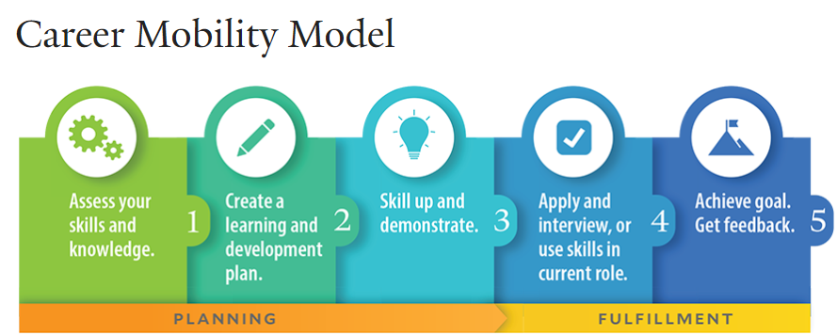
In this session, we will focus upon 4 planning activities:

- Deepen self-insight
- Develop an initial career goal & development plan knowing it may change over time
- Research roles and uncover people and practice opportunities to experiment, learn, and prepare for change
- Confidently solicit support

Step 1: Deepen Self Insight

Assessments are a great tool to reflect upon different job options. Below are two resources that may be helpful to gain new perspectives on roles that fit with your values, skills and interests:

MyPlan Career Values Assessment
This is a quick, online card sort of 20 items and shares a career comparison chart to see how up to 780+ careers align with factors that are associated with your values. Working in a role that aligns with our values leads to greater job satisfaction. An account will need to be created, using license code N7JCFQV6. To access it:
Click on https://careerservices.wayne.edu/readiness/tools/my-plan and "New Users" to create a free account in left menu. Select the free values assessment.

O*Net Online/Career One Stop Values, Skills, and Interest Assessment Options
This has three assessment options - no account needed & all are free - and also shares great research resources to learn about careers. The interest assessment shares your RIASEC score that we'll potentially reference more in the session, the skills assessment shares career matches, and the values assessment just highlights aspects that lead to job satisfaction. To access it:
Click on: https://www.careeronestop.org/ExploreCareers/Assessments/self-assessments.aspx

Reflection questions:

What career values surfaced that feel non-negotiable?

What jobs surfaced as being closely aligned to those values? Did this surprise you? Do any represent roles you’d like to learn more about? Which one/s, if so?

Step 2: Develop Initial Career Goal & Development Plan

These can change over time, but are helpful to guide us as we begin our learning about different options and see how they fit with our interests. Share below:

Your career goal/s: _____________________________________________

Not sure how to respond? Consider:
- What you hope to do more of one day in your current role.
- What you seek to do more of in a new job/career one day. Why?
- How these items align with your career values, interests, and/or skills as discovered in the assessments.

Bonus points!
- It might be helpful to reflect upon your past work experiences in preparation to look ahead to new roles. See the Staff Career Development Goals and Development Planner for more. And as leaders, the questions we ask to guide a career conversation can be critical. See the Leader Discussion Planner for more.
- Once you have determined a job/role you’re interested, research what the U. S. Department of Labor says this job does and the knowledge/skills needed to be successful. Go to onetonline.org and search the job to get started.

Career Development Plan

To begin learning more about this career and building new knowledge/skills to prepare, create a plan. This can be a great tool to share & refine with others – and to request support!

How we learn best often follows the 70/20/10 rule:
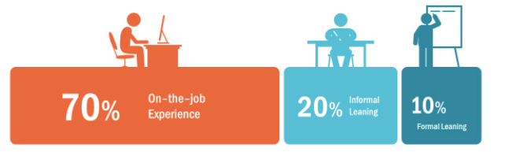

Examples of formal/informal career learning options can vary based upon where you’re at today. Some ideas for inspiration are noted below:

Not yet sure what I want to be “when I grow up”: | Thinking about ways to grow in my current role: | Would like to learn more about a different WSU job:
- O*Net Online assessments & research options  - CareerOneStop.org  career videos and other resources  - WSU contacts - request for job shadowing or informational interview | - Learning about team member strengths & requesting they share something that interests you  - Cross training  - Professional associations  - Certifications and Facebook groups for certification prep  - Book clubs  - Requesting a challenging assignment  - Teaching others what you know  - Leading process improvement  - Documenting procedures in a knowledge base | - Ask your HR Consultant or Business Affairs Officer about different roles at WSU that match your interests  - WSU Organizational Charts  - WSU job descriptions  - Networking via committees  - Wayne Women Lead provides a mentoring process  - Seek a WSU mentor  - Request job shadowing and/or informational interviews to learn about new roles
What else might you do to begin your career learning?

Return to your career goal and O*Net Online research and share below what you’d like to learn to begin preparing for the job duties/tasks of this role and how you’ll go about obtaining this learning:

Knowledge/ skills sought | Formal & informal learning options to obtain those knowledge/skills

How will you get started? What support specifically are you seeking? Highlight these below:

My next steps will be: _____________________________________________

Resources I will need are: __________________________________________

My anticipated timeline is: _________________________________________

Step 3: Research Roles and People/Practice Opportunities

Everyone needs a career coach, sponsor/s, mentor/s and advisor/s!

Circle the names in your network map above of individuals who may be a good fit for these roles based upon their ability to role model work done in the job that interests you, help you set goals to learn more, provide advice to get started, and open their network, assign challenging assignments, etc. Use the below charts to learn more about these roles.

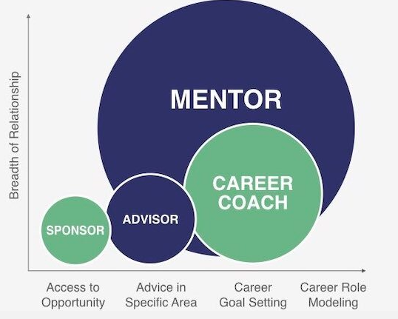

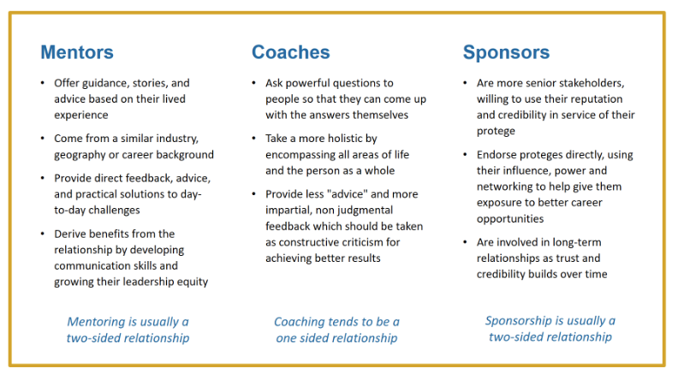

Broadening our Network

Your network can help you as you begin seeking support from others. Think through your connections, including those from your current WSU team and other WSU colleagues as well as friends, family and others. Jot down names in the circles provided within the graphic below of those you’d like to reach out to. Some brainstorming prompts:
- Who does your key network members know/hang out with? Check their social media networks to see who is in their LinkedIn network, for instance, and ask if they might introduce you.
- Think about WSU colleagues broadly inside and outside your School/College/Division (SCD) doing work that interests you. Not sure who they might be? Ask your HR Consultant or BAO for an organizational chart or view the people directory at WSU’s website.
- Include others that might be relevant, including:
  - Alumni from your college program
  - Professional association members
  - Others you’ve worked with in the past
  - Community members, non-profit or other volunteer group members, and others you’ve worked with in some capacity before, even if it wasn’t for pay. Ask them about others they might know who could help.

Using the diagram below, jot down names in your network who may be good individuals to start with as you seek support, informational interviews, job shadowing, and mentoring:

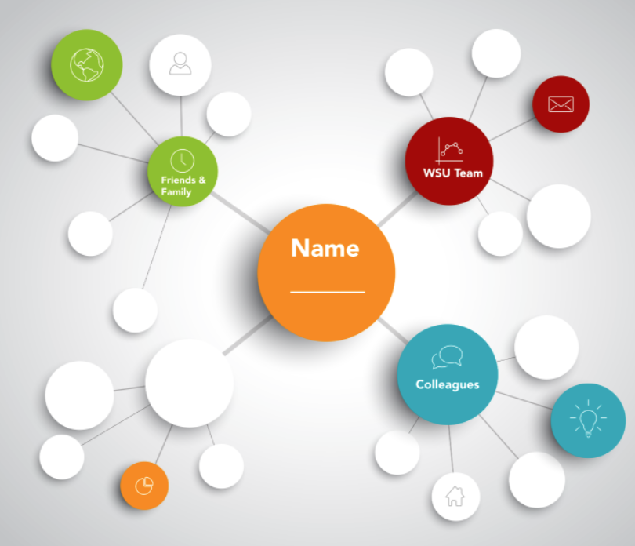

Step 4: Solicit Support

When asking individuals in your network for support, prepare your ask or “script” including:

- Your career interests, desired work environment/tasks/responsibilities, and results you’d like to attain.
Bonus points for:
- Highlighting why you’re so passionate about this work
- Remaining positive in sharing the kinds of work you’d like to contribute to in order to benefit our WSU community.
- Including why this individual came to your mind as being someone well suited to connect with on the topic.

- What you’d like to learn more about when it comes to this new work, perhaps the knowledge/skills discovered in O*Net Online.

Bonus points for asking if the individual might be willing to:
- Share how they prepared for their job
- Allow you to observe a meeting or participate in a related task to gain some exposure to the new tasks
- Share the name of someone in their network they would recommend you connect with to learn more
- One thing you’d like to ask for help with. Be specific and make it easy for the individual to say yes.

Sample email scripts for customization when requesting support:

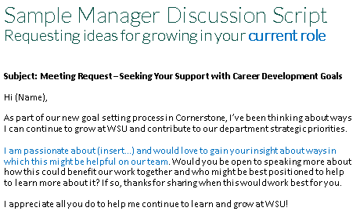

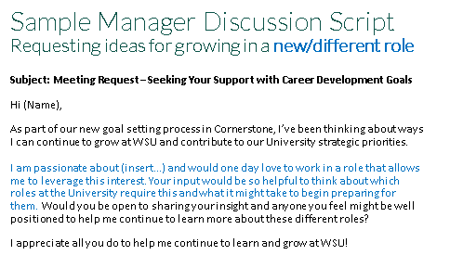
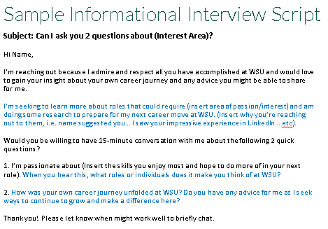

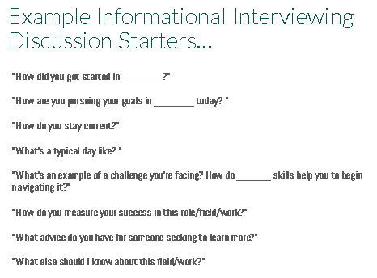

Step 5: Get Resume-Ready for Open WSU Postings

What do you want a WSU hiring manager to know about you?
Share below two things that make you uniquely qualified for the open WSU non-academic role you’d like to apply for:
1. ________________________________________________________________________

2. ________________________________________________________________________

Resume Format Template Resources
As we review example resumes and discuss what WSU recruiters like most in a format, consider if downloading a resume template is right for you.
- MS Word
- Nova Resume
- Standard Resume

Creating Compelling Accomplishments With “Top” Resume Verbs
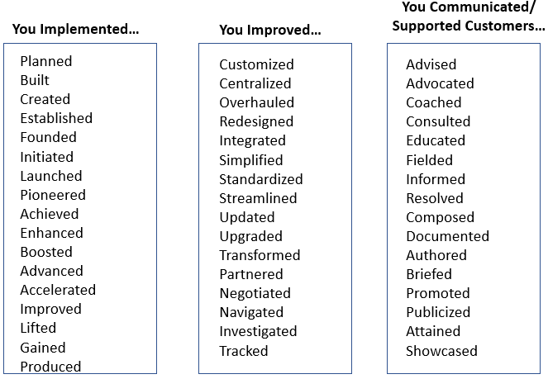

Resume Checklist
Before finalizing your resume, check to ensure that it contains:
- Name and Contact Information
  - Contact information clearly stated; campus and permanent addresses both listed if appropriate
  - Email address
  - LinkedIn and other professional social media links
  - Link to electronic portfolio

- Professional Highlights, Specific Areas of Interest and/or Accomplishments in Career Field
  - Briefly described accomplishments that demonstrate your skills and experience in alignment with the needs of the open position. These might include your top three or four accomplishments, skills, or competencies listed as bullet points.
  - Industry buzzwords and keywords included for search engine optimization when posting it on job boards
  - Listing of most notable career-related extracurricular activities
  - No personal data or potentially discriminatory data as it pertains to extracurricular organizations

- Professional Experience
  - Experience section lists notable accomplishments rather than all duties and projects
  - Descriptive (if not actual) job titles
- Position title, begin date to end date, name of employer, city, state
- Add a brief description of your responsibilities, achievements and competencies gained
- List all major or related work experiences, whether paid or volunteer
- If there are gaps of time in your history, make sure to include any work experience that accounts for your time out of school

- Education
  - List most recent first, dates of attendance
- Doctoral, Graduate and Undergraduate Institutions
  - Degree listed first, college/university second
  - GPA listed if over 3.0
  - Major GPA listed if over 3.0 and your overall GPA is under 3.0
  - Graduation date listed, even if you have not yet graduated
- Honors, Certifications
- Include awards and/or scholarships received during school, research and career

- Professional Associations
- List any professional organizations of which you are a member and the year you joined
- Include any leadership positions you may have held

- Community & Volunteer Experience
  - Include the most important long-term activities you were involved in, including committee work, community service projects, and student organization involvement
  - Say how often you volunteered, i.e. weekly, monthly
  - Include older activities only if they are extraordinary or applicable to career field
  - Highlight achievements of experience – specific outcomes obtained or workgroups led

General (format, content checkpoints)
  - 1-2 pages only, unless you have significant previous experience
  - Spelling and grammar checked (automated and manual) and thorough proofread
  - Use traditional fonts, 10 point to 12-point size (12 point is best)
  - Margins no less than 1" and no more than 1.5"

Applicant Tracking System Online Testing Websites
Does your resume pass the “ATS” test? Check for the inclusion of key words in the job posting and try:
- Jobscan
- Resume Worded

Curriculum Vitae Checklist

Before finalizing your CV if applying for an academic role, check to ensure that it contains:
- Name and Contact Information (Header)
  - Contact information clearly stated; campus and permanent addresses both listed if appropriate
  - Email address
  - LinkedIn and other professional social media links
  - Link to electronic portfolio

- Education
- List most recent first, dates of attendance
- Doctoral, Graduate and Undergraduate Institutions
  - Degree listed first, college/university second
  - GPA listed if over 3.0
  - Major GPA listed if over 3.0 and your overall GPA is under 3.0
  - Graduation date listed, even if you have not yet graduated

- Awards/Honors
- Include awards and/or scholarships received during school and career. Include a description of the award if it is not obvious
- Graduation with distinction (i.e. magna cum laude)
- Relevant and or most important awards from previous degrees can also be listed

- Research
- List any research activities and projects you assisted with or conducted alone. Include your role as a Research Assistant, Primary Investigator, etc.
- Include the title of the project, lead advisor or researcher (if any), institution at which it was conducted, and date. Give a one sentence description of your duties
- Describe funding awards

- Publications
- List, in bibliographic reference style, any abstracts, papers, or articles published or in the process of being published
- Do not include publications that have not yet been accepted

- Presentations
- Include any research, professional, or poster presentations conducted at conferences, lectures or symposiums. List date and place presented.
- Work Experience
  - Experience section lists notable accomplishments rather than all duties and projects
  - Descriptive (not actual) job titles
- Position title, begin date to end date, name of employer, city, state
- Add a brief description of your responsibilities, achievements and competencies gained Be concise yet inclusive of the most important attributes for your objective
- List all major or related work experiences, whether paid or volunteer
- If there are gaps of time in your history, make sure to include any work experience that accounts for your time out of school
- Include experiences when you mentored others.

- Service/Co-Curricular Activities (Extracurricular Activities)
  - Include the most important long-term activities you were involved in, including committee work, community service projects, and student organization involvement
  - Say how often you volunteered, i.e. weekly, monthly
  - Include older activities only if they are extraordinary or applicable to career field

- Memberships and Affiliations
- List any professional organizations of which you are a member and the year you joined.
- Include any leadership positions you may have held

- Special Skills
  - This section can be a catch-all for any additional skills you wish to highlight such as computer skills, sign language, etc., for example: Languages (i.e. Spanish: fluent spoken)
General (format, content checkpoints)
  - 3-5 pages only, unless you have significant previous experience
  - Spelling and grammar checked (automated and manual) and thorough proofread
  - Use traditional fonts, 10 point to 12 point size (12 point is best)
  - Margins no less than 1" and no more than 1.5"

Resume/CV Do’s and Don’ts

Do
- Make sure your name is clearly visible. Consider using a larger font or bold font.
- Spell-check and grammar-check your resume—twice; then have at least two other people do it for you again.
- Be mindful of acronyms, spell out on first reference
- Be strategic with use of career related key words (saturate your resume with key words for search engine optimization on job board websites)
- Use consistency in your layout to make your resume visually appealing
- Make your language professional and concise so that it’s easy to read and understand
- Use bullet points, bold, italic and underline to emphasize and enhance format/structure
- Adjust your margins on sides, top, bottom to check overall format
- Use print-preview function to check for overall visual flow and appeal of each page
- Maximize your prime real-estate (upper center area of your resume’s first page)
- Use action-oriented words (verbs) to draw focus on your related skills and accomplishments
- Ask someone who knows you (friend, colleague) to proofread and share input.
- Keep a PDF version for electronic use and hardcopies on hand for in-person use

Don’t
- Use an unprofessional email address (i.e. videogaminggenius@personal.com)
- Over-format it! Too many fonts types and sizes can be distracting for the reader
- Include personal data or potentially discriminatory data
- Write an essay! Be brief and succinct (use bullet points)
- Make your document too busy with formatting or gimmicks
- Forget to check your spelling and grammar. Use appropriate style guide to ensure accuracy

Step 6: Interview SMART

Your Interview Plan
Creating targeted “selling statements” helps you to showcase 3-5 accomplishments that will really capture the interest of the interviewer. These statements should relate to key position requirements that you anticipate the interviewer will want to focus upon and show how you’re uniquely qualified to excel in that area. To begin, scan the job description/posting to determine the key position responsibilities and jot them down in the space below.

Essential Position Requirements/  Responsibilities | Accomplishments  Brief story highlighting how you’ve demonstrated the skill in the past and the outcome that resulted

Interview Preparation Checklist
Congratulations! Your resume or vitae got noticed and you’re scheduled for an interview! What can you do before the big day to ensure you’ll make a positive impression? Consider:
Know Names, Titles, Location & Dress Code
Be sure to politely ask the individual who scheduled the interview for the name/s of the individual/s with whom you will be meeting, their title/s and location. It’s also helpful to confirm the dress code to ensure you “look like you belong”.
Do Your Research
In order to stand out and ask really good questions, you’ll need to know about the organization. Review their website as well as perform a general internet search to identify organizational structure, products/services, training programs, etc. It may also be helpful to see the LinkedIn profiles to understand the background of each interviewer as well as consider relevant professional associations for key industry trends, terminology and salary reports.

Create Interview Questions & “Selling Statements”
Come to the interview with a few questions that highlight something you learned from your research about the job or the organization. Because this is a ‘sales’ experience, you’ll also want to bring a few notes about how your accomplishments relate to job requirements.

Arrive Prepared
Bring a copy of the job posting/job description, enough copies of your resume to enable each interviewer to have one, a notepad/pen as well as the questions you’ll want to ask and “selling statements” you’ll want to share. Arrive at least 10-15 minutes early, allowing enough time to collect yourself and mentally focus upon the key requirements of the position.

Practice
What can you do in advance to practice? Videotape yourself answering common interview questions with a friend, drive to the interview location at the same time of day as the interview is scheduled so that you know how much time to allot for the commute and try on your interview outfit to be sure it fits.

Example Attire

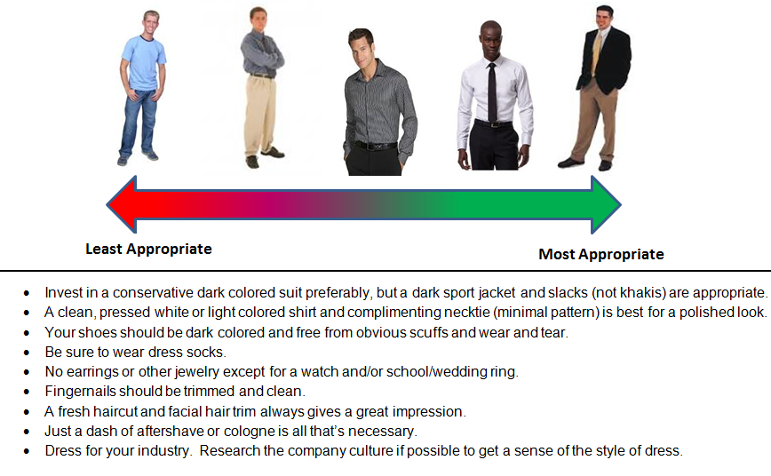

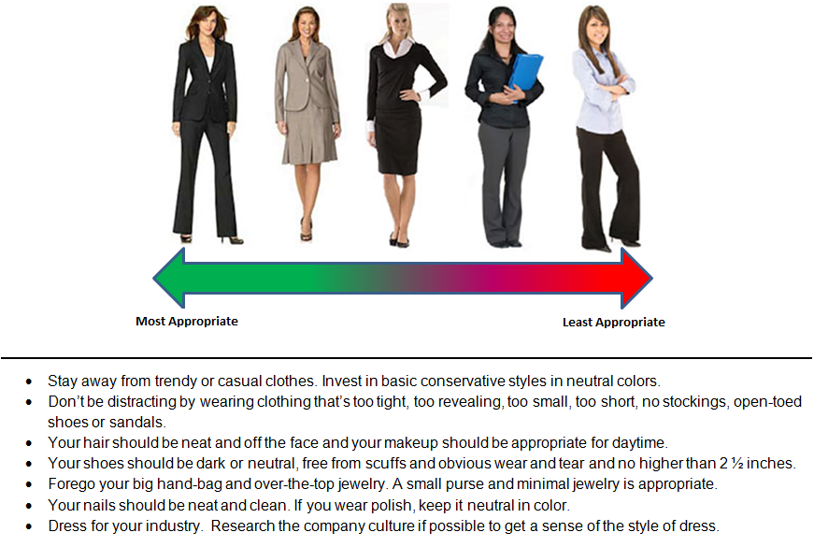

Common Interview Questions
Anticipate and practice answering common interview questions until you feel your responses reflect your skill and personality, not what you think the interview wants to hear. Nowadays, savvy interviewers use behavior-based interview questions to understand how a job candidate performed a required skill/attribute in the past. These questions usually begin with a “Tell me about a time when… “, “When faced with ___ situation, describe what you did” or “Describe an example of when you….”.

Example Behavior-Based Interview Questions:
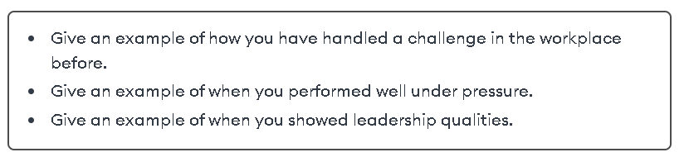
Other Commonly Asked Interview Questions
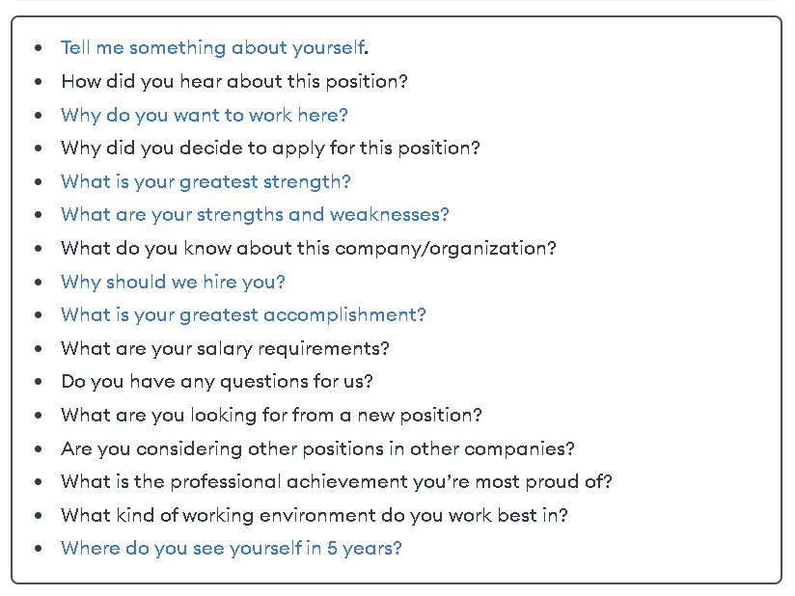
In responding to these questions, remember the STAR approach:
Situation | Briefly set up the situation by describing it briefly (i.e. who, what, where, when & how)
Task | Explain the task you had to complete, or the problem you had to solve
Action | Describe the actions you took to complete the task or solve the problem
Result | Close by explaining the result of your efforts. Include numbers whenever possible, i.e. the number of kids tutored, the dollars or percent increase you achieved in fund raising, etc.

Activity
Jot down your response to an example interview question. Note it may or may not be a behavior-based question – use your best judgment to incorporate element/s of the STAR that seem appropriate but don’t worry if you don’t have them all covered. Seek to be succinct!

______________________________________________________________________________

______________________________________________________________________________

______________________________________________________________________________

______________________________________________________________________________

In small groups, one team member will be the interviewer and ask the question you received. Another team member will be the observer. At the end of your response, the observer will share feedback on:
- Was the question answered directly?
- Did the response contain any of the STAR elements? How did that work out?
- What did the interview candidate do well?
- What could the candidate consider for continuous improvement

Preparing Your Own Interview Questions

Questions You Might Ask
- Why did the person most recently in this position leave?
- What would you like done differently by the next person who does this work?
- How has this position evolved since it was created?
- How would you describe the atmosphere of this department?
- What have you enjoyed most about working here?
- What are two/three most important things you would want the person in this position to accomplish right away? What is the top priority for the person in this position over the next three months?
- What are the success factors for a person to be effective in this position? What have past employees done to succeed in this position?
- What are some challenges that will face the person filling this position?
- Do you have any hesitations about my qualifications?
- When are you looking to make a hiring decision?
- I’ve enjoyed our meeting and I’m very interested in going forward. Where do we go from here?

Interview Do’s and Don’ts

Interview Do’s

- Dress appropriately for the industry. Err on the conservative side. Your personal grooming and cleanliness should be impeccable.
- Arrive 10-15 minutes early. Phone if you will be delayed (don’t be!). Check out your appearance in the restroom when you first arrive.
- Arrive alone. The employer wants to see you, not your friends or family. If you get a ride, have them drop you off at the entrance and ask that they wait outside the building until you come out.
- Be friendly and considerate to all individuals you meet in the process. Be patient when waiting. When possible, read any company literature that is available in the waiting room.
- Introduce yourself in a confident way to the receptionist, and identify by name the person you wish to see, the time of your appointment and the job you’re interviewing for.
- Listen to be sure you understand your interviewer’s name and the correct pronunciation.
- Even when your interviewer gives you a first and last name, address your interviewer by title (Ms. , Mr. or Dr.) and last name, until you’re invited to do otherwise.
- When introduced to the interviewer, shake hands firmly, green him/her by name and introduce yourself. Remain standing until you’re invited to sit.
- Sit still in your seat, avoid fidgeting and slouching.
- Be positive, enthusiastic and interested about the job, the company, the interviewer and yourself.
- Be pleasant, friendly and businesslike in your words and manners. Maintain eye contact without staring and ask questions that require more than a “yes” or “no” answer.
- Ensure your responses are professional and succinct, that they answer the question itself and provide specific examples whenever possible. Also strive to provide a positive ending. When possible, this ending should either include an accomplishment that you’re proud of and relates to the question – or should show how you learned something as a result of a situation.
- Be thorough in your responses to questions, while being concise in your wording.
- Ask for clarification if you don’t understand a question.
- Prepare and have ready extra copies of your resume, personal work samples, portfolio if appropriate, extra pens, reference list, note pad and personal appointment book.
- Be honest and be yourself – your best professional self.
- Seek to get to know the position and organization as much as you strive to sell yourself.
- Make sure you understand the employer’s next step in the hiring process; know when and from whom you should expect to hear next. Know what action, if any, you’re expected to take next.
- When the interviewer concludes the interview, offer a firm handshake and make eye contact. Depart gracefully.
- After the interview, make notes right away so you don’t forget critical details.
- Write and send a thank you letter to your interviewer within 24 hours.

Interview Don’ts
- Don’t fidget with your clothes, hair or jewelry
- Don’t smoke or chew gum or drink even if you’re invited to do so
- Don’t argue or tell the employer your troubles
- Don’t stress your need for the job
- Don’t use slang or profanity
- Don’t place your handbag or briefcase on the employer’s desk
- Don’t gossip or tell jokes
- Don’t sell yourself out of a job by saying negative things about yourself, peers or past employers
- Don’t focus on wages, benefits, or vacation
- Don’t mention personal or financial problems (health, family, etc.)
- Don’t be afraid to smile – do it a lot!
- Don’t make excuses – take responsibility for your actions and decisions
- Don’t lie – ever!
- Don’t treat the interview casually, as if you’re just shopping around or doing the interview for practice.
- Don’t give the impression that you are only interested in the organization because of its location, or employee discount or generous time off package, etc.!
- Don’t make the interviewer guess what type of work you are interested in – be prepared to share what you would like to do (ultimately) and why
- Don’t allow your cell phone to make a sound during the interview. If it does, ignore it. Don’t take a call – don’t look at a text message! Don’t take notes on it!
- Don’t pop your feet on the table while waiting for an interview to start
- Don’t wear flip flops, have too short of a skirt, allow undergarments to show, or wear too much jewelry or perfume

